Before proceeding further we need to know about KPI.

**KPI**

KPI stands for Key Performance Indicators. A KPI is a visual cue that represents the amount of progress made towards a particular goal.

**When to use KPI?**

We use KPI mainly in two conditions :

1. When to study the progress made towards a particular **target.**

2. When to analyze a **trend.**

• **KPIs for Total Miles, Revenue, Cost**

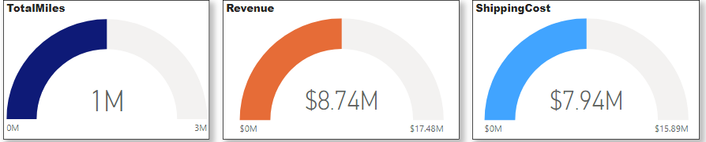

• **Revenue Vs Miles by Shipping State**

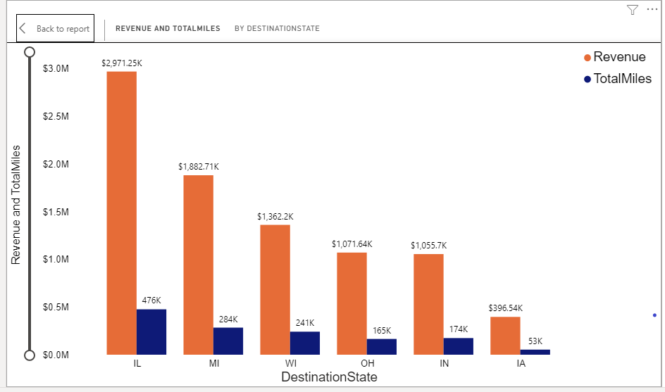

• **Revenue Vs Miles by Shipping City**

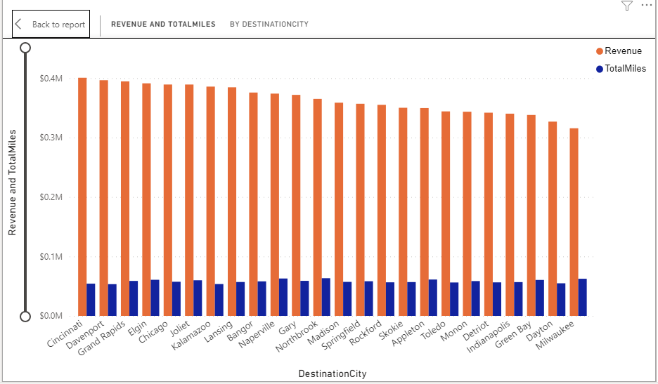

**• Total Trips Vs Trips by Trip Types**

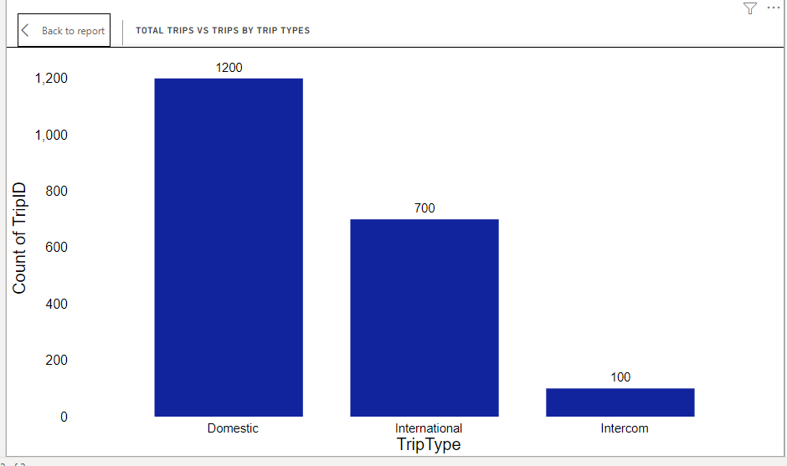

**• % of Trips by Shipping State**

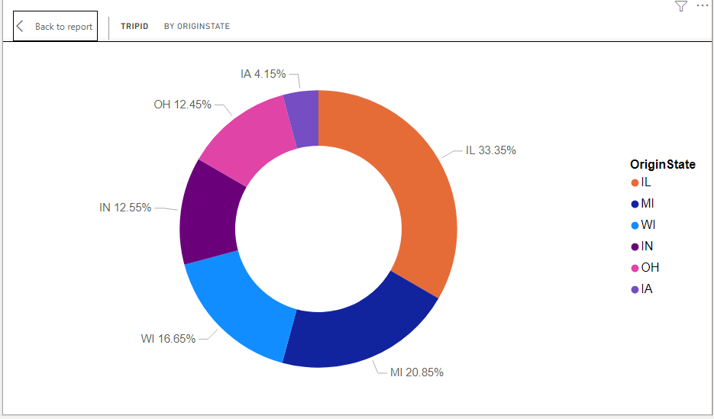

**• Revenue Miles vs Total Miles**

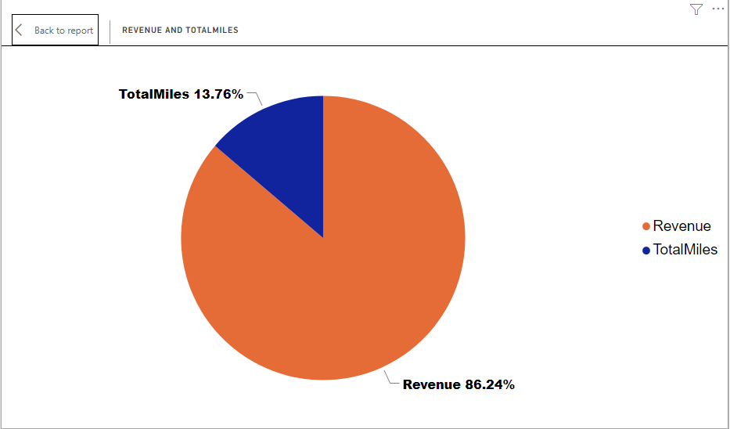

**Final Dashboard:**

